# **3. System infrastructure and architectures**

**3.1 Cloud-based IOT sensor system infrastructure design**

The real Smart Agriculture Network will contain from two main parts:

* Physical layer of equipment
* Cloud based software to collect and manage data and equipment

The diagram below shows those two elements:

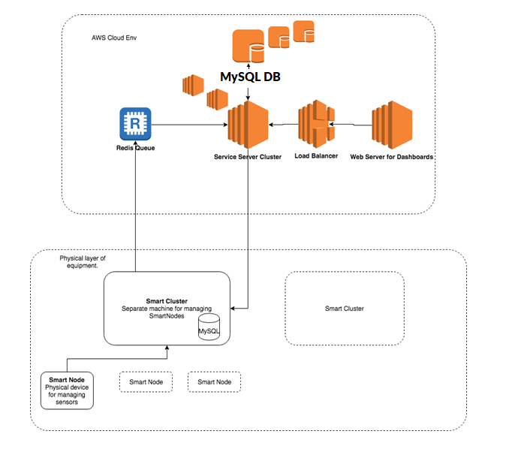

**3.1.1 Physical layer of equipment**

The Physical layer of equipment contain Smart Nodes and Smart Clusters.

*SmartNode responsibility is*:

* Collect data from sensors
* Collect health data of sensors
* Allow disable/enable, connect/disconnect different (supported) types of sensors
* Pass the information to other nodes

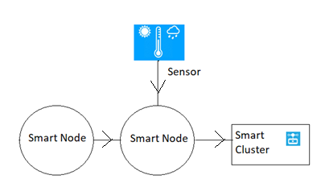

*SmartCluster responsibility is:*

* Register SmartNodes
* Collect data from SmartNodes with the intervals determined by configuration
* Collect health data from SmartNodes
* Push data into Queue (Redis Queue)

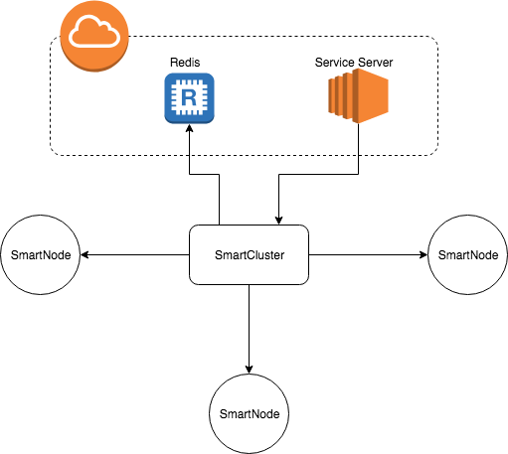

***For education purpose the Physical layer of equipments will be forge with cloud based applications which will mock the real devices by implementing appropriate API interfaces.***

***All below architecture and analysis will be based on this statement!***

**3.1.2 Cloud based software**

The Cloud based software will contain from the next main components:

* Service Server (Node JS)
* Queue (Redis)
* DataBase (MySQL)
* Web Server (Node JS)

*Service Server responsibility:*

* Manage and configure SmartClusters
* Pulling and transform Sensors Data and Health data from Queue and store it in DB
* Expose Rest API to access to Sensors Data

In terms of support horizontal scalability all Service Servers will be behind Load Balancer.

*Queue (Redis) responsibility:*

* Accumulate data in the queue
* Give back data from the queue

The main purpose to use Queue is to prevent data loss in case of Service Server maintenance or crashing.

*DataBase (MySQL) responsibility:*

* Store Sensors Data and HealthData
* Provisioning different types of searching requests
* Provisioning good horizontal scalability

In terms of horizontal scalability, which is for my opinion is very important for such type of data (sensors time series data) the most suitable DB is MySQL.

*Web Server (Node JS) responsibility:*

* Provide 3 types of dashboard for users (Farmers, IOT Support, Infrastructure manager)
* Users Authentication and Authorization
* User management functionality for 4th type of user - admin.

**3.2 Deployment-Oriented System Infrastructure**

Our Cloud Infrastructure Provider is AWS. For SmartNodes, SmartClusters, Service Server and Web Server will be used ec2 instances.

As a software deployment mechanism the docker image containing will be used.

The deployment process:

* Instantiate ec2 instance in AWS - Amazon Linux **AMI 2018.03.0** with Docker
* ssh into instance
* Run Docker image with appropriate settings

Security groups:

* Private access security group (SmartNode, SmartCluster, Queue, Service Server)
* Public access security group (Web Server)

In real life the Queue should have public access and SmartCluster should use authentication credentials to be able to push data into. In our education project we don’t need it since SmartNodes and SmartClusters will be run in Private Security Group.

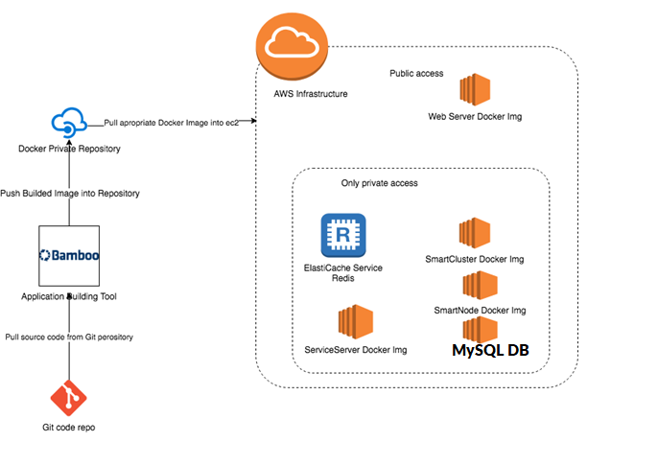

**3.3 System-Oriented Component Functional View**

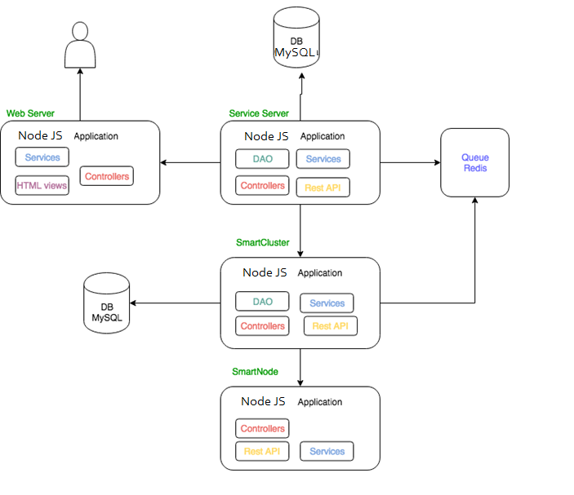

**3.4 Database design**

In our project will be used two types of DB: MySQL for Smart Cluster and MySQL for ServiceServer.

**3.4.1 MySQL for Smart Cluster**

This DB dedicates to store the SmartCluster related data like:

* Smart Nodes data (id, name, location, description, type, ip_address)
* Smart Cluster data (clusterId, name, location, description, config, ip_address, type)

Config data will contain: Smart Nodes status ping intervals, sensors data collecting intervals.

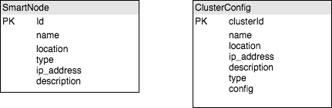

**3.4.2 MySQL for ServiceServer**

This DB dedicates to store:

* sensors time series data
* Smart Nodes statuses data

Sensors time series data.

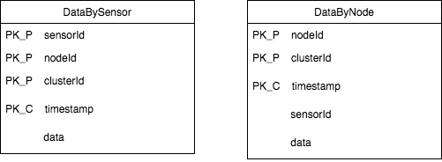

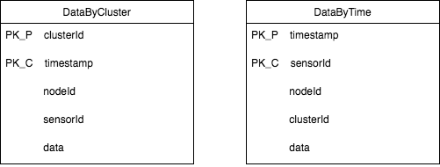

Statuses Data

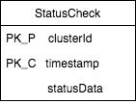

PK_P - Primary Key Partitioned

PK_C - Primary Key Clustered

**3.4.3 Redis Queue**

In purpose of buffering the data we are going to use Redis Queue. There are 2 types of messages:

* sensors data
* Smart Nodes statuses data

As data structure the JSON will be used:

*{“messageType”: MessageType, “content”: {contentJsonObject}}*

*enum MessageType:{*

*STATUS, SENSOR_DATA*

*}*